**NUTRITIONAL MEAL DROP**

**A COMMUNITY SERVICE PROJECT REPORT**

***Submitted by***

**H Nikhil Reddy (9919004106)**

**S Likhil Srinivas (9919004269)**

**M Jaipal (9919004177)**

**Y Pawan Kumar Reddy (9919004305)**

***In partial fulfillment for the award of the degree***

***of***

**BACHELOR OF TECHNOLOGY**

**IN**

**COMPUTER SCIENCE AND ENGINEERING**



**SCHOOL OF COMPUTING**

**COMPUTER SCIENCE AND ENGINEERING**

**KALASALINGAM ACADEMY OF RESEARCH AND EDUCATION**

**KRISHNANKOIL 626 126**

**April 2022**

**Major Design Experience Information**

|  |  |  |
| --- | --- | --- |
| Student Details | : | H Nikhil Reddy (9919004106)  S Likhil Srinivas (9919004269)  M Jaipal (9919004177)  Y Pawan Kumar Reddy (9919004305) |
|  |  |  |
|  |  |  |
| Project Supervisor | : | Dr. R Murugeswari |
| Project Title | : | Nutritional Meal Drop |
| Program Concentration Area | : | People who don’t have time to cook due to job busyness. |
| Subject(s) as  Pre-requisite | : | CSE18R173 – Design and Analysis of Algorithms  CSE18R212 – Machine Learning |
| Constraints | : | Food conveyance services are frequently late.  Client don't have the idea about the amount of food they are requesting. |
| Project Related to | : | Food Recommender and Delivery |
| Standard | : | IEEE P2796.1 – IEEE framework for the Internet of Food system applications |

**DECLARATION**

I hereby certify that the work which is being presented in the B.Tech. Community Service Project Report entitled **“Nutritional Meal Drop”,** in partial fulfillment of the requirements for the award of the **Bachelor of Technology in Computer Science and Engineering** and submitted to the Department of Computer Science and Engineering of Kalasalingam Academy of Research and Education (Deemed to be University) – Tamil Nadu., is an authentic record of my own work carried out during a period from December 2017 to April 2018 under the supervision of **DR.R Murugeswari**.

The matter presented in this thesis has not been submitted by me for the award of any other degree elsewhere.

*Signature of Candidate*

**H NIKHIL REDDY(9919004106)**

**S LIKHIL SRINIVAS(9919004269)**

**M JAIPAL(9919004177)**

**Y PAWAN KUMAR REDDY(9919004305)**

This is to certify that the above statement made by the candidate is correct to the best of my knowledge.

*Signature of supervisor*

**Date: Dr.R Murugeswari**

**Project Supervisor**

**Associate Professor**

**Department of CSE**

**Head**

Department of Computer Science and Engineering

Kalasalingam Academy of Research and Education (Deemed to be University)

**KALASALINGAM ACADEMY OF RESEARCH AND EDUCATION**

**SCHOOL OF COMPUTING**

**DEPARTMENT OF COMPUTER SCIENCE AND ENGINEERING**

**BONAFIDE CERTIFICATE**

Certified that this project report “**NUTRITIONAL MEAL DROP”** is the bonafide work of **“H NIKHIL REDDY(9919004106), S LIKHIL SRINIVAS(9919004269), M JAIPAL(9919004177), Y PAWAN KUMAR REDDY(9919004305)”** who carried out the project work under my supervision.

## Signature Signature

|  |  |  |
| --- | --- | --- |
| **Dr.P Deepalakshmi** |  | **Dr.R Murugeswari,** |
| **Head of the Department** |  | **Project Supervisor** |
| **Associate Professor** |  | **Associate Professor** |
| **Department of CSE** |  | **Department of CSE** |
| Kalasalingam Academy of  Research and Education |  | Kalasalingam Academy of  Research and Education |
| Krishnankoil-626126 |  | Krishnankoil-626126 |
| Virudhunagar District. |  | Virudhunagar District. |

Project Viva-voce held on

## Internal Examiner External Examiner

**ACKNOWLEDGEMENT**

First and foremost, we thank the ‘Supreme Power’ for the immense grace showered on us which enabled us to do this project. We take this opportunity to express by sincere thanks to the late**, “Kalvivallal” Thiru T. Kalasalingam, Chairman, Kalasalingam Group of Institutions, “Illayavallal” Dr. K. Sridharan,Ph.D., Chancellor, Dr. S. Shasi Anand, Ph.D., Vice President**, who is the guiding light for all the activities in our University.

We thank our Vice chancellor **Dr.R. Nagaraj, Ph.D.,** for guiding every one of us and infusing us the strength and enthusiasm to work over successful.

We wish to express our sincere thanks to our respected Head of the Department **Dr.P.Deepalakshmi** , whose moral support encouraged us to process through our project work successfully.

We offer our sincerest gratitude to our Supervisor, **Dr.R Murugeswari**  enthusiasm and immense knowledge.

We are extremely grateful to our Overall Project Coordinator, **Dr.T Dhiliphan Rajkumar**  for constant encouragement in the completion of the Community Service Project.

Finally, we thank all, our Parents, Faculty, Non-Teaching Faculty and our friends for their moral support.

**ABSTRACT**

These days there are a wide variety of portable applications for weight and diet management. Besides, there are not many examples of food recommender systems that provide to the user’s nutritional facts about reasonable food decisions. An enormous number of people are extraordinarily busy with their positions, loved ones, and other basic exercises, which doesn't take into account cooking. This could lead a poor diet routine and lasting health consequences. We need to solve this issue by using a web-based methodology. Clients can use our web page to pick their eating routine and food sources they like and dislike, and our computation will make a custom and individual step by step weekly plan. we will guarantee client get all of the enhancements and supplements they need, notwithstanding eating routine they follow. However, we don't stop there. We get together with eateries and other cooking accomplices to truly get ready and convey all dinners from the delivered feast plans to chosen regions. The article presents the architecture and the execution of the product. We additionally portrayed the algorithms, apparatuses and modules utilized in our work. As a result, our work will assist busy people in obtaining nutritious food on a daily basis while avoiding any negative consequences. Our website is very responsive, so users can use the website on any device, i.e., mobile, tabs, laptops.

**TABLE OF CONTENTS**

|  |
| --- |
| **ABSTRACT** |
| **LIST OF TABLES** |
| 1. **LIST OF FIGURES……………………………………………………….9** |
|  |
| **CHAPTER I INTRODUCTION………………………………………….10** |
|  |
| **CHAPTER II LITERATURE SURVEY………………………………….11**   * 1. Meal Recommender System   2. Food Ordering and Delivery   3. Food reviews Sentiment Analysis   **CHAPTER III** |
| **SURVEY QUESTIONS AND NEED ANALYSIS ……………..……………….13**  3.1 Survey Questions  3.2 Need Analysis  **CHAPTER IV OBJECTIVE………………………………….………………15** |
| **CHAPTER V** |
| **METHODOLOGY………………………………………….……………..………16** |
| * 1. Web Development   2. Machine Learning Multinomial Naïve Bayes      1. Data Construction      2. Stopword Construction      3. Features Construction      4. Classification      5. Experimental Results |
| **CHAPTER VI RESULTS AND DISCUSSION………………………………..19**  6.1 Website  6.2 Machine Learning |
| **CHAPTER VII CONCLUSION AND FUTURE WORK…………………23** |
| **REFERENCES ………………………………………………………………………24** |
| **APPENDICES ………………………………………………………………………..25** |
|  |

**LIST OF FIGURES**

|  |  |
| --- | --- |
| **FIGURES** | **DETAILS** |
| Figure 1 | Figure 1: website block diagram |
| Figure 2 | Figure 2: research overview diagram |
| Figure 3 | Figure 3: shows the weekly plan recommendation for user |
| Figure 4 | Figure 4: shows the received orders from user |
| Figure 5 | Figure 5: shows the confusion matrix of Gaussian naïve bayes |
| Figure 6 | Figure 6:shows the confusion matrix of Multinomial naïve bayes |
| Figure 7 | Figure 7: shows the confusion matrix of Bernoulli naïve bayes |
| Figure 8 | Figure 8:shows the confusion matrix of logistic regression |
| Figure 9 | Figure 9: shows precision comparison between four algorithms |
| Figure 10 | Figure 10: shows recall comparison between four algorithms |
| Figure 11 | Figure 11: shows the accuracy comparison between four algorithms |
| Figure 12 | Figure 12:shows the positive and negative reviews percentage given by users in our website |

**CHAPTER 1**

**INTRODUCTION**

The Omnifood project plans to develop a meal recommender and delivery framework that allows clients to arrange their number one food that contains the ingredients they like. It is a framework that permits clients to arrange their favourite food in a way that contains the ingredients they like. In particular, there are numerous applications for requesting food from various cafes in urban areas. Some systems support group orders too, but a user cannot have the option to change the ingredients of something they do not like. This model works well when a user can add ingredients they like and remove those they do not. Based on the user's taste, we will cook and deliver the meal. As an example, Swiggy and Zomato can be mentioned, where users can order their favourite food from their favourite restaurants and have it delivered within 30 minutes and get accurate information about restaurants as they provide menus, reviews, and ratings. At present, the vast majority are occupied with their positions, which doesn't allow for cooking. Searching for food items daily to eat is a time-consuming process, and they don’t get the option to change ingredients. They may not get all the required nutrients, which might lead to a poor diet. Software like Omnifood could greatly improve the situation. This will produce a customized week plan for every client. On the website, clients can change ingredients, swap entire meals, or even add their own recipes, so that clients get their favourite food with enough nutrients. Omnifood provides a web interface for users to place orders and view food items recommended by the software. The interface also provides the possibility of recommending a personalized weekly plan for each client. Omnifood can fill orders that include items from specific categories such as vegetarian, non-vegetarian, and gluten free. The system also has an administration interface where admin can track users and food items statistics and manage the received orders. The work of the delivery-oriented management system can be accessed on any browsers and on any screen size. This interface is responsive and compatible with all new and old browsers.

**CHAPTER 2**

**LITERATURE SURVEY**

In this section, we present related literature. Our problem combines two components: restaurant meal delivery and arrival time estimation. There is only limited work in this domain. In Subsection, we present the two most related works, followed by an overview of works on the individual components in Subsections. The work generally firmly associated with our own is that of (2018) Liu et al., (2019) Ulmer and Thomas, and furthermore (2020) Zhu et al. Liu et al. (2018) consider meal conveyance from a single restaurant, from where drivers pick up dinners for a large number of clients. Along these lines, the cost of task choices is uncertain as well. Liu et al. (2018) anticipate the drivers' routes in a data-driven approach.

**2.1 MEAL RECOMMENDER SYSTEM**

The personalised food suggestions were recently introduced by [1] Manuel B. Garcia (2019). This paper proposed the improvement of a web-based application called "Plan-Cook-Eat" that can produce customised eating routine plans as per a person's necessities. Six enlisted nutritionist-dietitians served as a panel of human master validators, and 24 normal clients filled in as application testers for assessment utilising a mixed-strategies approach. A recommended system for adaptive diet monitoring was recently included by [2] Agapito G. and Calabrese B. (2016). This paper proposed DIETOS (DIET Coordinator System), a recommended framework for the versatile delivery of nutrition substances to work on the personal satisfaction of both healthy individuals and people impacted by ongoing diet-related illnesses. The proposed framework can assemble a client's wellbeing profile and give an individualised nourishing proposal as per the wellbeing profile. The profile is made using dynamic constant surveys, ready by clinical specialists and accumulated by the clients.

**2.2 FOOD ORDERING AND DELIVERY**

Our problem is the combination of nutritional food delivery and sentiment analysis on food reviews. The restaurant meal delivery problem (RMDP) was recently introduced by [4] XU Hongzhen, Tang Bin, and Song Wenlin (2009). This paper presents an integration of wireless communication technologies and web administration technologies to realise a wireless food ordering framework. In this framework, it carries out wired and wireless data access to the servers and food ordering functions through desktop and desktop PCs and mobile devices such as PDAs over a wired and wireless integrated local area network. For ordering food and delivery an application was developed by [3] Cristina-Edina Domokos and Barna Séra (2018). The article presents the design and execution of the product framework. The innovations, tools, and techniques utilised during the development process are also portrayed.

**2.3 FOOD REVIEW SENTIMENT ANALYSIS**

Sentiment analysis is one way for classifying files in order to identify positive and negative criticism. Customer satisfaction is a key component of customer service. Customer behaviour is currently the subject of a variety of online reviews, such as on ride marketing consultant. A restaurant is a business that requires a more elevated level of regard for client support through reliably improving client assistance. An Analysis of TripAdvisor Restaurant Customer Reviews Using Naive Bayes characterised by [5] Rachmawan Kelly Rossa Sungkono, Adi Laksono (2019). The discoveries uncover that those strategies precisely anticipate client responses, and that the Naive Bayes method is more accurate than Text Blob sentiment analysis, with a one-of-a-kind accuracy of 2.9 percent.

**CHAPTER 3**

**SURVEY QUESTIONS AND NEED ANALYSIS REPORT**

* 1. **SURVEY QUESTIONS:**

1. **Strategies you follow to decide food quality?**

* Ingredient Specifications
* Product Formulation/Recipe
* Manufacturing Procedures
* Packaging and Labeling

1. **What amount of time does it require to convey the order?**

Our conveyance hours are from 8:00 AM to 8:00 PM.

1. **How much time it takes to deliver the order?**

For the most part, it takes between 45 min and 1hr to convey the request. To meet great quality and due to significant distance or weighty traffic, conveyance could require many additional minutes.

1. **Do you support mass orders?**

To give all clients an incredible choice and to guarantee on-time conveyance of your meal, we demand clients to arrange mass amount no less than 24 hours ahead of time.

1. **Is our menu varied enough to satisfy every preference?**

This can assist you with sorting out whether or not your menu has something like one choice that fulfils every client.You can likewise, do a food checklist agenda to test a few choices.

1. **Did you feel that the eatery accommodated your dietary limitations?**

This can be basic Yes/No. Still guess you can check your clients with genuine limitations (like sans gluten or vegetarian).

1. **What Ingredients could you like us to offer?**

Customer satisfaction rates will improve if you add desserts and starters to your menu.

1. **Should we change our plan prices?**

Ensure that your prices satisfy most of the customers.

1. **Are our working hours advantageous for clients?**

Yes, it is advantageous for clients, but it would be better if you extended your timings up to 10 pm.

1. **Which is more convenient for customers when ordering food through an app or a website?**

**Both are convenient.**

**3.2 NEED ANALYSIS**

By this analysis we comprehended

* working strategies of Restaurants.
* steps to keep up with food quality.
* how we can oblige restaurant in view of dietary plans.

This aided us to

* produce customized week after week plan for clients.
* know how to give all supplements, regardless of anything else diet they follow.
* realize how packing plays a significant part for keeping up with food quality.

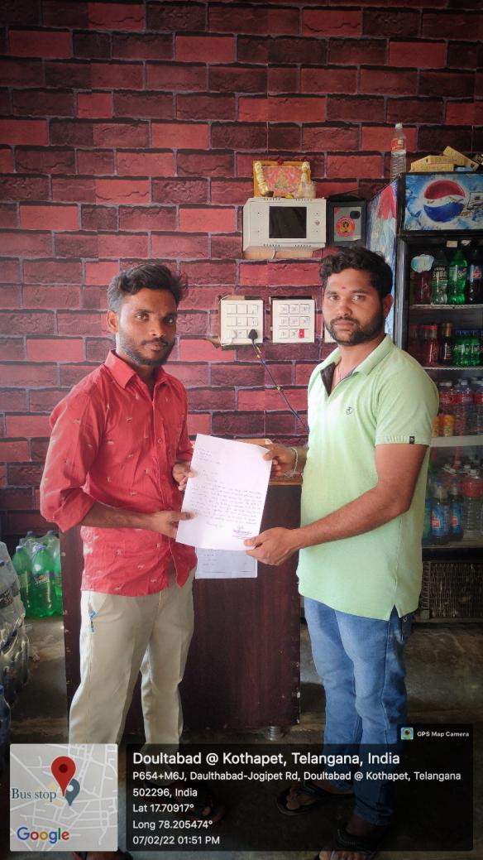

**CHAPTER 4**

**OBJECTIVES**

* Most people are very busy with their jobs. which doesn't leave much time for cooking and might lead to a poor diet.
* We want to solve this problem by using a web approach that create a custom and individual weekly meal plan.
* We partner with cooking partners to actually cook and deliver all meals from the generated meal plans, in selected cities.
* All this will be packed up in a monthly subscription, where users can choose between receiving one or two meals per day of every month.

**CHAPTER 5**

**METHODOLOGY**

**5.1 WEB DEVELOPMENT**

Significantly centered around customer prosperity through a daily eating routine. By far, most are especially busy with their positions, occupied with their timetable and other huge tasks, which doesn't take into consideration cooking. This could lead to a poor eating routine and enduring wellbeing outcomes. We want to solve this problem by using an approach. Clients can utilize our application to choose their eating routine and food sources they like and dislike, and our website will make a custom and individual week by week meal plan. But we don't stop there. In selected cities, we partner with restaurants and other cooking partners to actually cook and deliver all meals from the generated meal plans. All this will be packed up into a monthly subscription where users can choose between receiving one or two meals per day, every single day of the month. The smart 365-day food subscription that will get you eating healthy again your personal tastes and nutritional needs.

In this section, we characterize the issues encountered during food ordering and delivery based on previous research. They just recommend the diet plan. Most people are busy with their jobs, which doesn’t leave much time for cooking. Looking for food items day to day to eat is a tedious process. They don’t get the option to change ingredients, and they may not get all the required nutrients, which might lead to a poor diet.

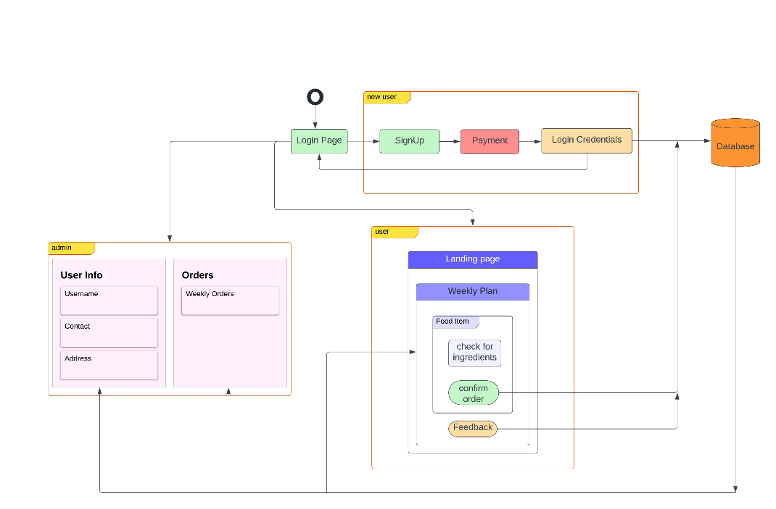

Fig. 1. Website Block Diagram

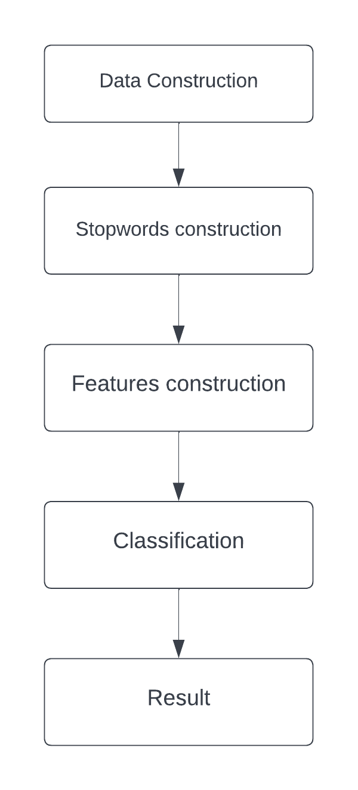**5.2 MACHINE LEARNING MULTINOMIAL NAÏVE BAYES**

Fig. 2. Research Overview Diagram

Fig. 1 indicates the flow from statistics production to sentiment type. The flow is split by 4 components, the first element data production, the second one component is Stop words Construction, and the third part feature creation divided by 2 different methods that we want to examine the use of Context vectorizer Stop words and using Context-primarily based Stop words.

* + 1. **Data Construction**

There is 1 dataset used in this study. The dataset is a food review of our websites that have a variety of meals. The topic is the food reviews obtained from our website, and we are using a Kaggle data set for train and test data. The dataset consists of customer reviews and labels sentiments. Each dataset has been allotted a positive (1) or negative (0) label based on each review sentiment. We can't indicate the number of positive and negative reviews a dataset can contain; it is based on the customers.

* + 1. **Stopword Construction**

Stopwords are meaningless words. The presence of Stopwords make the category have a lower accuracy. Removing stopwords can improve the very last end result. In this study, When we evaluate the 2 stopwords, That is the General stopwords as well as context-primarily based stopwords, General stopwords are received from present Count Vectorizer features. While context-based totally Stopwords are obtained by way of trying to find positive and negative ratios in the dataset. Second, classify the phrase: is it a stopword or not? One manner That may be used is via locating the ratio of advantageous frequencies to the entire. The fine recurrence results in a better quality proportion. Divided by way of overall frequency, as may be seen in Equation (1) underneath. Then we can finish the phrase stopword is in the equation or not below. For instance, the phrase "is" The phrase "is" cannot be It is used to distinguish a sentiment. It is really more difficult. Because it has an ambiguous context.

Ratiopositive = positive frequencies / Total (1)

Stopwords{IF Ratiopositive >= 0.4 AND Ratiopositive<=0.6} (2)

* + 1. **Feature Construction**

In this segment, we focus on producing functions from a overview csv, And optimizing it. We used Count Vectorizer to generate functions, and we use Stopwords to optimise the feature. In this phase,  We use 2 exceptional techniques to evaluate them. There is the use of  Stopwords on Count Vectorizer and context-based totally stopwords. Count Vectorizer, refers to a document and converts into frequency representation. Frequency is an effective technique for determining the load for  Each characteristic We used the Count Vectorizer Sklearn  approach in Python to make functions on this examine. The result of the capabilities may be huge and can consist of noisy and irrelevant information.

**5.2.4 Classification**

In this segment, we run four different algorithms on out dataset i.e. Gaussian Naive Bayes, Bernoulli Naive Bayes, Multinomial Naive Bayes, Logistic Regression. For algorithm evaluation we used results of precision, recall and accuracy of four algorithms.

**5.2.5** **Experimental Results**

From the above results we can see that Multinomial Naïve Bayes excels in all evaluation parameters when compared to other three classification algorithms. So for our model we choose Multinomial Naïve Bayes classification algorithm.

**CHAPTER 6**

**RESULTS AND DISCUSSION**

**6.1 WEBSITE**

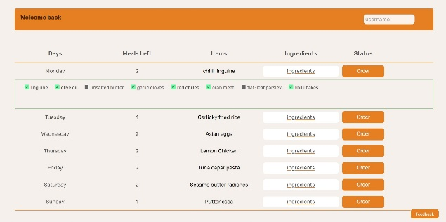

*Fig. 3 shows the weekly plan recommendation for a user*

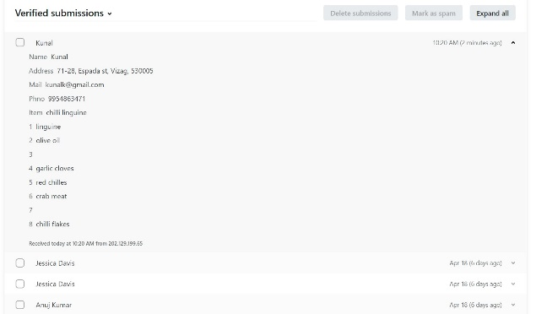

*Fig.4 shows the received orders from users.*

**6.2 MACHINE LEARNING**

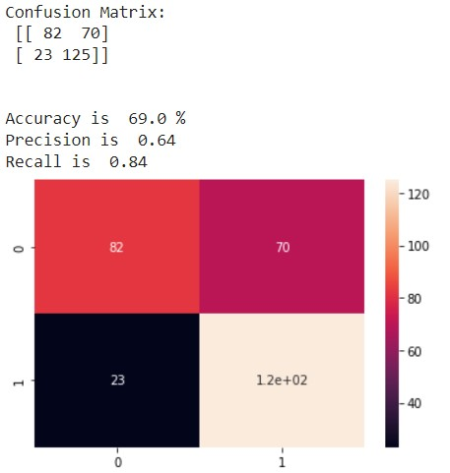

*Fig. 5 shows the confusion matrix of Gaussian Naïve Bayes*

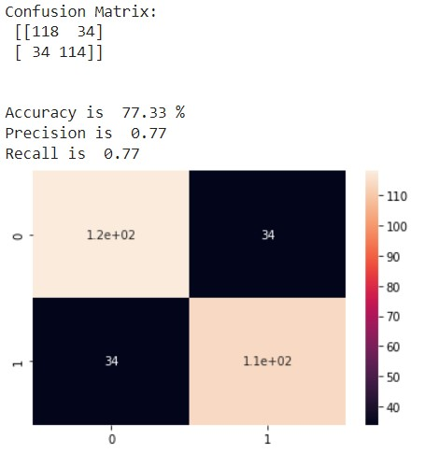

*Fig. 6 shows the confusion matrix of Multinomial Naïve Bayes*

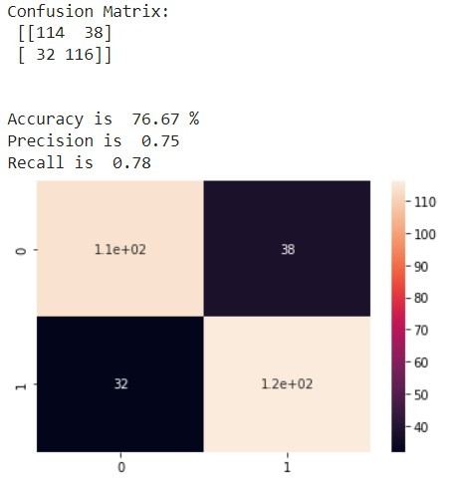

*Fig. 7 shows the confusion matrix of Bernoulli Naïve Bayes*

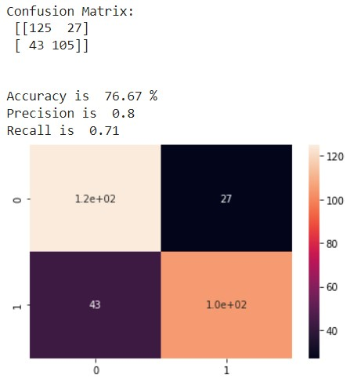

*Fig. 8 shows the confusion matrix of Logistic Regression*

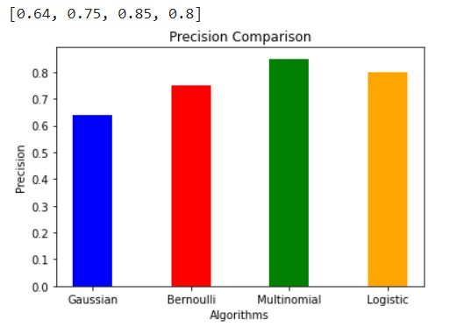

*Fig.9 shows the precision comparison between four algorithms*

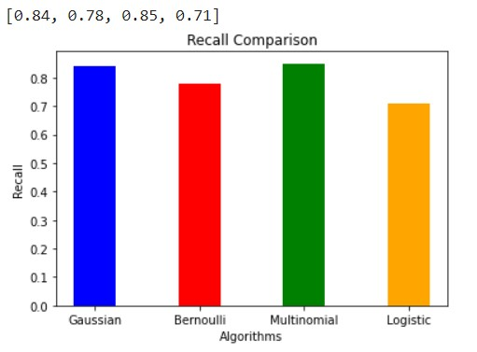

*Fig.10 shows the recall comparison between four algorithms*

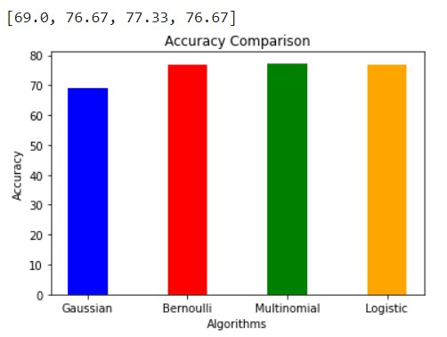

*Fig.11 shows the Accuracy comparison between four algorithms*

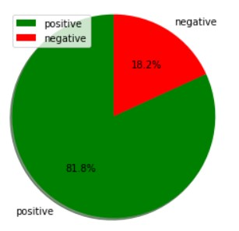

*Fig. 12 shows the positive and negatives reviews percentage given by users in our website*

**CHAPTER 7**

**CONCLUSION AND FUTURE WORK**

In this project, Within the Omnifood project, a software system has been developed to help users busy with their jobs. Clients can order 1 or 2 meals per day through our website. The menus, users, and orders can be managed by the administrators. The delivery process is supported by the web application: the couriers are immediately informed about new orders; they can accept deliveries receiving all the required information. During the advancement cycle new functionalities arose as additional improvement prospects:

* An interface for restaurant owners for directly managing their offers;
* After placing an order the customer should receive a message with the estimated time of delivery;
* A mobile application version;
* Google Maps integration into the application, to navigate the delivery personnel from the current location to the delivery address;
* A stand-alone mobile application used by customers for placing order

**REFERENCES**

1. Manuel B. Garcia. "Plan-Cook-Eat: A Meal Planner App with Optimal Macronutrient Distribution of Calories Based on Personal Total Daily Energy Expenditure " IEEE Access (2020)
2. Agapito G., “DIETOS: a recommender system for adaptive diet monitoring and personalized food suggestion,” Fourth International IEEE Workshop on e-Health Pervasive Wireless Applications and Services 2016.
3. Cristina-Edina Domokos., "Netfood: A Software for Food Ordering and Delivering" SISY 2018 • IEEE 16th International Symposium on Intelligent Systems and Informatics • September 13-15, 2018, Subotica, Serbia
4. XU Hongzhen., "Wireless Food Ordering System Based on Web Services." IEEE 2009 Second International Conference on Intelligent Computation Technology and Automation.
5. Rachmawan, Kelly, et al. "Sentiment Analysis of Restaurant Customer Reviews on TripAdvisor using Naïve Bayes." 12th International Conference on Information & Communication Technology and System (lCTS) IEEE 2019.
6. Unggul Widod Wijayanto, et al. "An Experimental Study of Supervised Sentiment Analysis Using Gaussian Naïve Bayes."  IEEE 2018 International Seminar on Application for Technology of Information and Communication (iSemantic).
7. Nourin Islam, Nasrin Akter. et al. " Sentiment Analysis on Food Review using Machine Learning

**APPENDICES**

